Life stages
Name:
Date:

Draw a line matching the person with the life stage.
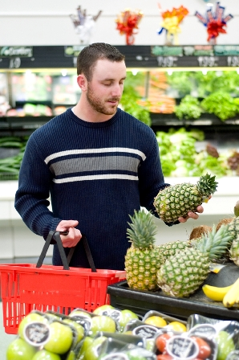

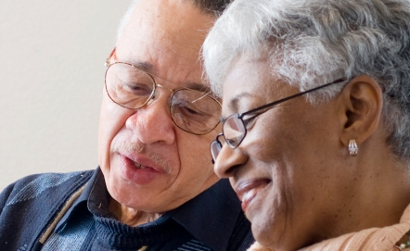
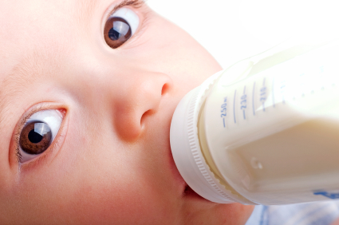


Teenager
Baby and infant
Child
Adult
Older adult

Pregnant woman
Teenager

Suggest examples of food and drinks each person may consume.

