Student name:
Date:

Factors affecting choice case studies

- Read through the following case studies, identifying factors which influence that individual’s diet, food and drink choice.
- Underline the factors which affect food choice.
Karolina
Karolina is taking a trip to the cinema to watch a new film with friends from school. She enters the cinema and can smell fresh popcorn being prepared. She is not particularly hungry, but the smell reminded her of last time she was at cinema and had the delicious popcorn. As her friends are all having a snack, she decides to get a small popcorn. The food vendor explains there is a deal where you receive a free drink when you buy a large popcorn. Karolina thinks this is good value for the money, so buys a large popcorn, planning to save some for the next day. Karolina is engrossed in the film and eats all of the popcorn.

Lukas
Lukas has been diagnosed with coeliac disease. He is having breakfast at a hotel on a business trip. He requests a glass of milk, a banana and 2 slices of toasted gluten free bread with spread from the hotel. When it arrives, he checks to see if it was prepared in a toaster bag, to avoid cross contamination. After finishing breakfast, Lukas takes a yogurt from the buffet as he knows he may need more calcium compared to the general adult population, due to having coeliac disease.
Marie
Marie is a keen swimmer and trains 6 days a week. She knows that she needs to eat well to ensure she performs at her best. Her mother helps her prepare healthy meals to bring into school. Her friends are often concerned with their body image and trying out new diets but Marie ensures she eats healthily.
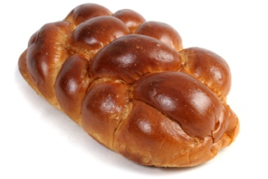
Francesco
Francesco is Jewish. He does not eat pork or shellfish and only eats other meat which has been slaughtered in a kosher way. In his kitchen, his family has separate pots, pans, utensils, cleaning equipment and plates for meat and dairy foods. Meat and dairy food are not consumed at the same meal. On Rosh Hashanah, Francesco and his family consume round challah to symbolize the cycle of life and the years.
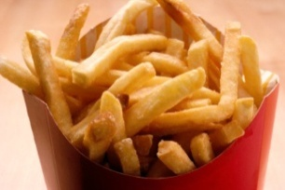
Lucia
Lucia has had a stressful day at school and has not had time for lunch. Although she has ingredients at home, she feels hungry and sees many signs and posters advertising a fast food chain on the way home. She decides to stop at the fast food restaurant to pick up dinner for the night. The portion sizes are bigger than she would have at home but so not to waste money, Lucia finishes her meal.

- Write a brief summary of some of the factors that have influenced your food choice today.

______________________________________________________________________________

______________________________________________________________________________

______________________________________________________________________________

______________________________________________________________________________

______________________________________________________________________________

______________________________________________________________________________

______________________________________________________________________________

______________________________________________________________________________

______________________________________________________________________________

______________________________________________________________________________

