European food investigation answer sheet

List three ingredients used to make a croissant.
Three from: wheat flour, water, milk, yeast, salt, sugar, butter and egg.

Which country does a croissant come from?
France

In which country is bigos a national dish?
Poland

Name three ingredients in a bigos.
Three from: sauerkraut, meat, meat products, onions, herbs, spices dried mushrooms, red wine and prunes.

Which country does paella come from?
Spain

Draw the flag of the country below:
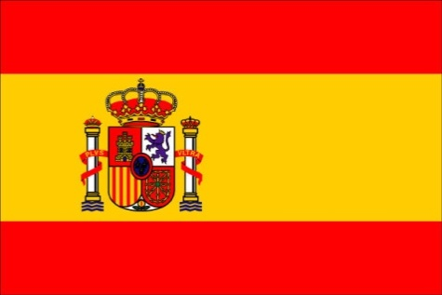

Which country are köttbullar from?
Sweden

Name two foods normally served with köttbullar?
Two from: boiled potatoes, mashed potatoes, lingonberry jam, cream sauce/gravy and pickled cucumbers.

Which country is pizza from?
Italy

Name three toppings you might have on a pizza?
Three from: cheese (e.g. mozzarella), meat (e.g. pepperoni), fish (e.g. tuna) vegetable (e.g. peppers), fruit (e.g. pineapple) and herbs (e.g. basil).

